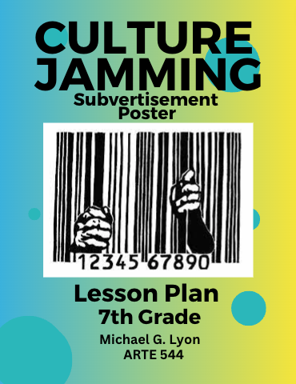

Clinical Teacher Name: Michael G. Lyon

Clinical Teaching Dates: 10/3/23, 10/10/23, 10/17/23, 10/31/23, 11/7/23, 11/14/23

Lesson Title: Culture Jamming Logo Poster

Grade Level: 7
Number of Students:13
Time available for this Lesson: 4 Hours
Central Focus (Big Idea):

Students will learn that art and advertising can be used to convey specific messages that influence consumers in multiple ways. Students will learn that marketing and advertisement use visual cues to convey messages that guide consumer knowledge and sway opinion.

Social Issues/Concepts of the Lesson Essential Questions:

How can advertising as a part of a larger global visual culture influence buying decisions, reinforce stereotypes, and form the social opinions of youth cultures?

How might youth cultures become aware of the covert and manipulative tactics advertisers and marketing companies utilize when trying to target adolescents as an audience and why?

How can the presentation of contemporary artists at the middle level highlight and forefront a visual resistance to such manipulative tactics?

How can adolescents use art to express individual voice and a point of view through a visual counternarrative that transforms the original advertisement into a subvertisement with a new individualized message?

How can the creation of a mixed media, stencil printed subvertisement poster help 7th grade students be critical of their new own message in how it undermines original intended message advertising?

Illinois Arts Learning Standards:

Anchor Standard #: VA: Cn11.1.7
Enduring Understanding: Analyze how response to art is influenced by understanding the time and place in which it was created, the
available resources, and cultural uses.

In this lesson: Students will define Culture, interpret existing corporate logos, and examine their own interests in a social issue.

Anchor Standard #: VA: Cn10.1.7
Enduring Understanding: Individually or collaboratively create visual documentation of places and times in which people gather to make and experience art or design in the community.

In this lesson: Students will discuss and learn advertisement, sketch logos, and discuss where/why marketers designed and placed their intended message, then when/why subvertising matters in message as protest.

Anchor Standard #: VA: Re8.1.7
Enduring Understanding: Interpret art and generate meanings through describing and analyzing feelings, subject matter, formal characteristics, art-making approaches, and contextual information and identify key concepts.

In this lesson: Students will discuss and critique as a class using new vocabulary and identify key aspects in their work used to deliver their message.

- Objectives  - Visual cues selected by marketing and advertisers significantly convey messages desired to influence and procure opinion with sales.  - Symbolism, repetition, aesthetic imagery is utilized to convey precise messages, though even sometimes deliberately indirectly delivered, all have an influential visual and psychobiological response.  - Utilizing the same techniques marketing and advertising companies, students will draw, print, and deliver messages that clearly define definitive redirection from a current mass produce media logo/message to explore how the message can newly change.  Relating art to context (personal, social, cultural, or historical perspectives) while providing opportunities for student choice (of content, methods, or styles)  Students will explore subvertisements of contemporary artists, research how original message can be reconstrued to a more accurate, personal message more appropriate to their social issue. | IALS Goal Codes
1.1 Conceptual/Cognitive Objectives:  OBJECTIVE I:  Given a presentation on defining Cultural Jamming, advertising techniques and subvertising, students will clearly identify and evaluate aesthetic clues that convey messages in advertising.  OBJECTIVE II:  Given an ad on smoking Marlboro Cigarettes, students will successfully evaluate, discuss, and assess what the advertisement is also trying to sell if you smoke one smokes cigarettes.  OBJECTIVE III:  Given a definition of Subvertisement, think sheet and paper, students will artistically sketch and effectively incorporate a Subvertisement of their artwork/design.  Objective IV:  Given multiple current examples of subvertising, students will creatively design their own logo displaying a message of their own clearly changing a modern logo design to better signify their personal reality/understanding. | VA: Cn10.1.7  VA: Cn11.1.7  VA: Re8.1.7  VA: Re8.1.7
1.2 Artistic Skills Objectives:  OBJECTIVE VI:  Given a presentation on Cultural Jamming, students will cleanly map/draft an idea sketching of their thought process.  OBJECTIVE VII:  Given paper, colored pencils, air brushes, and a presentation preparing/making stencil, students will incorporate stencil use and utilize text in their work.  OBJECTIVE VIII:  Given markers, paint, magazines, and digital prints of contemporary advertisement, students will thoughtfully declare and develop a clear message in their artwork.  Objective IX:  Given an Artist Statement Think Sheet, an artist statement worksheet, students will write an artist statement clearly defining why and how they personally utilized culture jamming ideas and advertising techniques in their work. | VA: Cn11.1.7  VA: Re8.1.7  VA: Cn10.1.7

2. Assessment Criteria:
ASSESSMENT CRITERIA I:
Students identified aesthetic clues that convey messages in advertising.

ASSESSMENT CRITERIA II:
Students discussed and assessed what the advertisement is also trying to sell if one was to smoke their cigarettes.

ASSESSMENT CRITERIA III:
Students incorporated a subvertisement element in their artwork/design.

ASSESSMENT CRITERIA IV:
Students created their own logo displaying a message of their own clearly changing a modern logo design to better signify their personal reality/understanding.

ASSESSMENT CRITERIA V:
Students identified aesthetic clues that convey messages in advertising.

ASSESSMENT CRITERIA VI:
Students used paper and colored pencils to sketch and use text in their work/idea.

ASSESSMENT CRITERIA VII:
Students used paper and colored pencils to sketch and use text in their work/idea.

ASSESSMENT CRITERIA VIII:
Students used markers, paint, and digital prints of contemporary advertisement to declare and develop a clear message in their artwork.

ASSESSMENT CRITERIA IX:
Students displayed their work having an understanding in techniques used in advertising.

3. Learner Characteristics
It is vital for students of all ages to realize how they are targeted as consumers sometimes with false pretenses. This project investigates why, how, and when advertising is done in the way it is clearly and targeted age appropriately. Having the ability to have 7th grade students be concerned about this while also conveying their own personal understanding of their issue/ (including social issues) defines their place in society and clarifies they do not have to be victims/targets. Understanding the ruthless techniques of misinformation, almost subconscious and nonconsensual tactics of marketing companies is impowering and can be used against the company institutions themselves if successfully executed/taught.

3.1 Developmental Rationale:

Advertising is a very powerful tool used to entice and influence younger/all audiences more than ever. Attempts to make younger children learn appropriately in how they are targeted and made to believe conceptually through images needs to be recognized and learned. As Lowenfeld (1957) says, “During this stage, nine to twelve, the child is gradual moving away from a dependency on the concrete and is now beginning to deal with abstract concepts” (p. 313). This age is significant as a student becomes aware all that seems to be is not only concrete but can be misleading. The ways misinformation is provided in advertisement is extreme and inappropriate in many ways. This lesson plan allows a student to recognize the power of visual cues and aesthetics in advertising designed for consumers, but also addresses how the individual student can respond with their own, “more honest” interpretation with culture jamming together as a whole positively. Not only is it essential for a class to share altogether in how each other sees differently, and interprets, but it does so creatively while embracing the acknowledgment of how what everyone sees is uniquely perfect, accepted, and embraced…no matter what. This establishes a safe working environment where further risk will likely occur. With risk comes reward/discovery and a more intimate relationship with how one learns; especially how a student can exist as an artist/person individually. Nurturing this, similarly, to Beleky’s (1997) approach to teach like a Mid-wife, in the Mid-wife model, students will all-together access what advertising is trying to “sell” and “target” them with as the teacher guides them along. “Mid-wife teachers focus not on their own knowledge (as the lecturer does) but on the students’ knowledge” (p.218) If the students brainstorm and are guided through their own discussion using their own recognition/interpretation, the teacher can guide them through what also can be learned from it. (or needs to be learned) In this case, how advertising not only targets and tries to influence them, but how they can thwart the intent and come up with designs acknowledging what the advertisements should/can be instead more honestly appropriate to their development.

3.2 Students with Disabilities:

Any students with physical, cognitive, behavioral, or sensory special needs will be individually addressed beforehand. Any IEP’s including program/language of St. Mary’s assessment will be recognized and discussed before any lesson occurs. Adaption to the lesson could be done verbally, remotely, made in photograph format for participation and then graded/assessed with an appropriate separate rubric. This will be catered to individual needs of the student demanding individualized attention.

4. Literature

4.1 Rationale of this Lesson:
7th Graders continue to develop their own strong opinions on social issues and social groups for the first time in their lives at this age according to Lowenfeld. As a student learns more about themselves and desires to form group relationships, validation becomes more important from outside sources in their lives. As Wood states also at this age,” interest in man’s inhumanity to man: issues of fairness and justice; have a desire to serve others” also becomes more apparent to nurture this growth and concern as students develop” (Wood, p. 156). It remains vital that this outside validation comes in the form of truthful influence and self-awareness to remain unbiased. Unfortunately, when it comes to marketing and outside influence, this is just not the case. Implementing a strategy for a student to become more self-aware of how advertising agencies target them with information and images becomes even more important should the information not be accurate or glamourized. As technology also has greatly been developed, including Artificial Intelligence, to ensure target audiences are achieved, to establish, protect and influence a company’s image, the necessity for a student to become aware of these practices becomes mandatory to establish their own opinion; to make unbiased opinions establishing their own identity. In Artificial Intelligence Applications for Marketing: A Literature-Based Study, similarly states referencing marketing tactics in companies by “using AI, they can quickly determine what content to target customers and which channel to employ at what moment, thanks to the data collected and generated by its algorithms.” (Haleem, 2022) In developing 7th graders, though not completely capable of understanding psychology and influence of the context our visual culture has, AI uses this knowledge to influence and target groups and individuals. The increased ability to interact with our youth and environment in how we consume and psychologically react recognized by AI shows an ever-needed demand to recognize the tactics companies use to target audiences. We then can be made more aware of nonconsensual marketing or becoming oppressed. Establishing the age-appropriate tools needed will help develop acute recognition of these tactics and lengths companies and outside influencers will go to influence them. As even some adults do not understand or read some of the tactics and abilities companies have when they must “agree” to “user agreements” prior to the use of programs, software, social media accounts and software updates they choose, it becomes even more important to acknowledge them as a free society. These marketing tactics provide the needed Big Data needed to use for their own interests with AI. Awareness becomes more important, to recognize and implement a safe defensive cognitive mindset in how greatly the environment/visual culture around us influences us. Especially as an individual in 7th grade develops cognitively at their age, understanding the world around them must be recognized and learned in how it influences their decision making.

4.2 Background of the Topic:
Throughout recent history, posters and advertisements have been recognized as powerful tools of influence. Similarly describing propaganda techniques and acknowledging their use in the past describing marketing strategy is well documented on how to sway public opinion, individual choice and increasing even sales as to why one’s individual or group’s psychology is relevant. How to harness this ability becomes even more prevalent as we study the past, such as at its highest form like Nazi influence; convincing mass population of righteous ideals so far from the truth genocide was justified by some in Germany. Controlling our visual culture and understanding its effect on the human mind starts with recognizing our past and its potential. Controlling any media, radio, advertisements, and visual culture around us equips us with the knowledge of how it influences and can be utilized more than those it influences. As even Paulo Freire recognizes in Pedagogy of the Hope,
-If the great popular masses are without a more critical understanding of how society functions, it is not because they are naturally incapable of it—to my view—but on account of the precarious conditions in which they live and survive, where they are “forbidden to know.” Thus, the way out is not ideological propaganda and political “sloganizing,” as the mechanists say it is, but the critical effort through which men and women take themselves in hand and become agents of curiosity, become investigators, become subjects in an ongoing process of quest for the revelation of the “why” of things and facts (Freire, 2021).
Knowing becomes extremely powerful as we recognize our past and now, even more with AI as a tool to keep those ignorant oppressed and controlled using the technology. Understanding these tactics and technology to our fullest critical capability becomes more important than ever to recognize prior to its implementation. As AI technology moves closer to our understanding of our own human development besides us also, it becomes more difficult to detect when it is used. Therefore, more imperatively, AI and marketing tactics recognized through cultural jamming can be recognized when we can implement creative tactics to question and investigate. Background and study of this influence is just now occurring as it is such a new and contemporary problem of ethics in AI marketing and influence. We can utilize Culture Jamming because we know it “is a new effective way to change share aspirations, express ideas, or criticize political issues or other forms of political associations” (Tibuta, 2016) Having our youth understand this, especially age appropriately as they develop in discussion, is vital to remaining critical, investigative, and free from biased influence.

Freire, P. (2021). Pedagogy of hope: Reliving pedagogy of the oppressed. Bloomsbury Publishing.

Haleem, A., Javaid, M., Qadri, M. A., Singh, R. P., & Suman, R. (2022). Artificial intelligence (AI) applications for marketing: A literature-based study. International Journal of Intelligent Networks.

Lowenfeld, V. (1957). Creative and mental growth.

Triputra, P., & Sugita, F. (2016). Culture Jamming Phenomenon in Politics (The Jokowi’s Memes in TIME Publication’s Cover and TokoBagus. com Advertisement). Journal of US-China Public Administration, 13(6), 386-396.

5. In-Class Activities:

Teaching Day 1

Time | Learning Activities | Purpose
10 Minutes | Orientation/Engagement/Motivation:  -Teacher Introduces themself while including personal background, interests, familiarities, boundaries, and expectations  “Why did I choose art and my prior career?  ‘Yes, I’m also known as Mr. Hard of hearing” and “Coach K (Kaizen)”  “What is Kaizen? I’m glad you asked and will find out…”  “Please introduce yourself and let us know one thing you would like to improve in your life.”  Students will be given a folder to keep their think sheets, sketches, and project.  -Introduce “fists up” to represent respecting and power they desire to learn individually. | Familiarizes students and develops a safe working, respectful environment/space.  Adds class management and silence to focus on their own learning while teacher provides guidance.
10 Minutes | Presentation/Explicit Instruction: -  Video Presentation slides on “What is Culture and Culture Jamming” Answer questions regarding community, family background and ethnic traditions.  “What do you think Culture Jamming is?”  (Stopping culture, protesting)  “Why change the message of a well-known Logo?”  (Familiarity, send a message, impact)  “Why use a well-known logo to send a different message across?”  (raises awareness, funny, discuss puns)  -Hand out think sheet  - General Idea think sheet.  “You are going to make your own culture jamming logo.”  “If you have an idea that comes to mind, write it down here also.”  -  -End presentation w/ question “What cultural or Social Issues are important for them.  Write down answers on board.  “What social issues are important to you?”  (Gender, Race, bullying, ageism)  “What companies do you think may contribute to your social issue?  (McDonald’s, Apple, Greenpeace)  -Write new answers on the board.  -Continue to ask guiding questions utilizing their answers on the board to develop more ideas from them on the board.  “Do you find it strange that advertisements pop up after you have just talked about something?” “Why do you think that is?”  (Tracking, cameras)  “Do you find it strange that advertisements pop up in the same subject after staring at something in a particular section at the store?” “How do you think this happens?” “Is it a good thing?”  (yes/No, to buy, sell) | Informative interaction with class  Iconic storage engaged with constant repetitive visual cues.  Open ended question to engage brainstorming personal issues treating to the student.  Iconic storage is engaged with constant repetitive visual cues.  Promotes active listening and engagement forwarding the creative thought process working together as a community/social group. community and
10 Minutes | Presentation/Explicit Instruction:  -In depth discussion of Marlboro advertising Ad  -Discuss visual cues, symbolism, and aesthetics. Answer questions about imagery being cool, feeling freedom, clean/healthy environment, feeling safe with guns, independence.  “Why would an advertisement or movie video like for you to feel happy, safe, or like you are making the right choice?”  (Want to be and feel like the message, convince you)  “Do you think companies mislead you in the message they wish to deliver?  “How?”  (lie, mislead, trick)  -Discuss then the student example of a Subvertisment on the Marlboro ad’s symbolism, Skeletons, being trapped, placement of imagery/composition invoking feelings of certainty,  “How honest do you think the groups of advertising minds/marketers are thinking when they target an audience?”  (not much, sometimes good)  -Use specific student examples of Dunkin Doughnut and Red Bull defining why the students chose to change the message to what they did.  “Do you think all natural ingredients are used In Dunkin?”  “How is the use of font and color perhaps utilized in their logo?”  (like candy, clean, bubbly, sweet)  “Do you think bright, smooth, fluffy characteristics have anything to do with the desired message?”  “Who knows the Red Bull slogan or what Red Bull is supposed to do?  (It gives you wings, superpowers, energy)  “Does the image of a bull have meaning?”  (You will be strong, courageous)  “Are chemicals or caffeine somehow emphasized instead?”  (No, energy though with wings)  “What is the clear message the student example simply explains?”  (skeletons=death, “Marlhorror” mean to be scared  “How is this ironic/”  (opposite of Marlboro companies ad, humorous because it isn’t what we typically see)  -Define Ironic- the expression of one's meaning by using language that normally signifies the opposite, typically for humorous or emphatic effect.  -Discuss use of text, irony, puns and why they direct attention why they provoke student thoughts  -Introduce teacher example  “What is the message?”  (Barbie promotes bad body image, upset princess, we should be aware Barbie sets precedence on body image for what girls should want)  “How has the logo been manipulated?”  (Text, Hand graffitied over logo, image of barbie has a brain on it)  “How is it a social issue?”  (Self-promotion of unrealistic expectations, to bubbly/stupid for girls to look up to, money focused on materialistic possessions) | Visual Cue for current misleading propaganda visual imagery discussion  Defines vocabulary, how symbols and imagery are used, and emotional responses therefore received.  Provides solution for advertising with truer intent.  Solidifies symbolism definition discussion.  Compares and contrasts propaganda targeting in terms of self-interest.  Develops conscious of marketing goals are particular in delivering messages.  Instills interest and investigation in how any logo or advertisement might otherwise be catering to their self-interest, besides now knowing now that honest and integrity should be questioned.
10 Minutes | Independent Practice/Application:  Start Projects  -Silent Think sheet of personal social issues/ problems/concerns for students to deliver 10 examples/issues of concern or logo ideas they may think they could use.  “Write at least ten social issues on your think Sheet.”  “Write down at least 5 company logos you can think of and/or companies you have concerns about.”  -Use Chrome Books  “Use the Chrome Books to search together to assist each other with their idea?”  Perhaps search “What are less thought about, social issues?”  “What are your favorite companies and logos?”  “What are your least favorite companies and logos?”  “Please search ideas and company logos on your chrome books.”  Search for problems that those companies deal with  “How does your company deal with social issues that concern them/”  “How do you think you can raise issue with the problems that these companies create?” | Provides independent reflection, uninterrupted or influenced by their peers while addressing what they do care and are concerned about.  Technology tool to assist with brainstorming
10 Minutes | -Closure: Breakout groups of Three with personal think sheets  Raise your hand if all members of your group have their own idea within the group.”  “What are social issues of your group?”  “What social issues are they?”  “What is symbolism and what might you make to represent that in your project?”  “Think how you may be able to cut out your symbols and text.”  “Does the text or symbols uphold to the message you wish to deliver?”  “How does size or placement of symbols effect how a viewer may interpret an advertisement?”  “How will you emphasize symbolism in your project? Text? Texture? Size?”  “Put your belongings together and Chrome books away?” | Compares and contrast in discussion respectfully what may be more important for one, may be more or less important for another.  Helps brainstorm perhaps more issues than one student may have had to consider.

Teaching Day 2
Time | Learning Activities | Purpose
5 minutes | "Orientation/Engagement/Motivation  Reintroduce self.  “Who can tell me what culture jamming is?”  “Who has thought of a social issue related to a company you know?  ” Introduce proper blade safety | Provides safe use of blades and establishes the danger and respect that a knife is not a toy, but a tool.
25 minutes | Presentation/Explicit Instruction  X-Acto Demo  Painting Marker Demo/ Air brush/ demo presentation:  Work time  Personal questions one on one along these lines:  “What areas within your composition will utilize stencils?” “Will it be in text form of symbolism?”  -Final commitment to social issue and Logo and sketches  “Who hasn’t thought of an idea yet?  Individual consultations  “What will be painted, drawn in your logo?”  “How will you use stencil in your logo?”  “How is text used in your logo?”  Individual consultations  “What is your social issue?”  “How did you choose your logo?”  “What is the new message you are describing?”  “How else can you utilized text?”  Onomatopoeia=POW, WHAM, ARRRgh  -X-Acto Practice and cutting  “What symbols could you think of that have meaning towards your message?”  “How does a cracked heart convey emotional response?”  “Does the use of Emoji utilize symbolism with general message?”  Bring music | Introduces Air Brushing Skills and practice.  Introduces blade cutting skills.  Introduces Vocabulary.  Introduces vocabulary and will focus our artwork into only montage compositions
10 minutes | Closure  Review individual student work with the class and brainstorm helpful ideas.  -Message Sent=Message Received  Ask class the following questions.  What will clarify and simplify your message?  “Can you simplify your message that you are “sending” to increase your odds to be “received?”  -Clean Up and final assessment of group progress.  “Can you improve upon how you have cleaned before?” “How?”  “What group will be done first with their clean up?”  “Will group 1 check group 2’s table, 2 check 3, and 3 check 1 please?”  “Will the winner notify me next week whether they cleaned the room better than we found it?”-Final commitment to social issue and Logo and sketches.  “What will be painted, drawn in your logo?”  “How will you use stencil in your logo?”  “How is text used in your logo?”  -Paint booth Tarps  Individual consultations  “What is your social issue?”  “How did you choose your logo?”  “What is the new message you are describing?”  “How else can you utilized text?”  Onomatopoeia=POW, WHAM, ARRRgh  -X-Acto Practice and cutting  “What symbols could you think of that have meaning towards your message?”  “How does a cracked heart convey emotional response?”  “Does the use of Emoji utilize symbolism with general message?”  Bring music | Encourages teamwork and future planning as a group to work cleanly as you work.  Supports Kaizen  Introduces Air Brushing Skills and practice.  Introduces blade cutting skills.  Introduces Vocabulary
 | -Message Sent=Message Received  “Do you feel you should change anything?” “What?”  “How will you be using text in your project?”  Will it clarify and simplify your message?  “Can you simplify your message that you are “sending” to increase your odds to be “received?”  “Would more symbolism help?”  -Clean Up and final assessment of group progress.  “Can you improve upon how you have cleaned before?” “How?”  “What group will be done first with their clean up?”  “Will group 1 check group 2’s table, 2 check 3, and 3 check 1 please?”  “Will the winner notify me next week whether they cleaned the room better than we found it?” | Encourages teamwork and future planning as a group to work cleanly as you work.  Supports Kaizen

Teaching Day 3
Time | Learning Activities | Purpose
5 minutes | Orientation/Engagement Motivation  Review Culture Jamming  -Final discussion presentation of delivering a new subvertisement message in our culture jamming poster.  Use student example and briefly ask the class what is the culture jam in the work?  “What is Timmy/Tammi trying to say do you think?”  -Display visual student examples from presentation while students work on their design | Provides hands on learning and assessment of their own abilities in how they will be capable to utilize stenciling and air brushing in their work
25 minutes | Structured Practice/Exploration-Air brush practicing and tinkering with words and symbols.  “Why have you chosen the text and symbols you are using?”  -Discuss Use of sketches and mockup final piece for 2nd time with airbrushing  "Will you have to protect the rest of your work somehow when you airbrush?  “How?”  (carboard, tape, tarp) | Encourage safe exploratory environment without commitment and much needed practice
10 minutes | Closure  -Group discussion on foreseeable hurdles  “How are you doing on timing?”  “If you think you may run our or not have enough, how can we simplify the message to even clarify it more?”  (Text, less symbols, simplify background)  -Discussion on Message  “Is the message sent the message received?”  “How?”  (text is clear, image is clear, symbols are clear)  Final decisions on what teacher may need to provide:  “Does anyone need me to print anything for you to trace or cut for next week?”  Assess Printing art/logos at teacher’s home, etc.  Group clean up.  -Remind winner to supervise final clean up  “Who will clean up best this week?”  “Is the entire room better than we left it?”  “How does a clean and organized room promote better work?”  “Do you wish your peers to have the best opportunity to do their best work?”  “Does the room look better than last week?”  - | Empathize common problems together as a group. Discusses clarity and importance of messages.  Acknowledgment and confirmation of any assistance teacher will be able to provide in the making of the final artwork

Teaching Day 4
Time | Learning Activities | Purpose
5 minutes | Orientation/Engagement Motivation  Review safety protocols on blade safety and final concerns  -Workday: Cutting Final Stencils if need be and magazine logos  -Announce final draft from sketches need to be complete at this point and ideas halted even if extra elaboration is desired.  “Does anyone feel their message is not coming through in their artwork?” | Establishes final work needs to be completed
25minutes | Structured Practice/Exploration-Final one on one consultations to develop the clear message students wish to convey in their work.  Structured Practice/Exploration  -Complete final work  -Write down notes on their rough drafts/sketches with them to start artist statement.  “Why did you choose this logo?”  (social issue, make an impact)  “Why do you think the message is conveyed/”  (it says so, obvious)  -Use think sheet/sketch to write down why and how they came up with the idea. Why this social issue is important to them.  -Keep think sheet for display with artwork | Allows project with time remaining.  Enables extra time for students ahead to continue to explore or start their artist statement.
10 minutes | Closure  “Have you tried the airbrush yet? How do you think is will help to clarify your message?”  (Symbolism, text stencil, simplicity=clarity)  -Class discussion on delivery and final presentation orientation.  “What makes someone focus on content within work?”  (color choice, looks nice, personal to them)  “Why is having less more?”  (if too busy the message is lost, too fancy may distract)  “Does neat or clean work help with this?” “Why”  (emphasizes it, doesn’t take away from the message)  -Group clean up  -Introduce spirit of Kaizen  “HOW did you learn last week that cleaning your environment/workspace improves performance of others?” | To add value to becoming always desiring to improve quality of work; to be able to communicate and be understood better.  Kaizen opportunity for class to achieve a cleaner room than we found it

Teaching Day 5
Time | Learning Activities | Purpose
5minutes | Orientation/Engagement Motivation  Review Blade safety, Air Brush/Painting techniques and importance of detail | Addresses presentation on cleanliness, neatness in contributing a message more impactfully.  Will enhance the opportunity that an even clearer image and message will be “sent” and “received” by audiences.
30 minutes | Structured Practice/Exploration-Bonus Work Time  -Final touch ups and layouts  -Discuss Needed modifications to complete work discussed with students individually  -Complete Artwork  -Follow up One on one consultations/conversations to ensure completed work | Needed for follow-up and any rework that may need to happen with guidance
5 minutes | Closure  Group clean up.  “Who can tell me the definition or what Kaizen means?”  “Are we going to end up cleaning the room likely better than we have before if we all honestly focus on Kaizen?” | Leaves no trace as if we were in the room

Teaching Day 6
Time | Learning Activities | Purpose
5 minutes | Orientation/Engagement/Motivation | To emotionally connect with students’ relationships with others and their work with how, why, and desires of outcome.  Reinforce cognitive memory echoically with vocabulary.
20 minutes | Presentation/Explicit Instruction  Presentation on artist statements  Use teacher example project as teacher example and artist statement.  “What is the social issue in the teacher’s example do you think?  (body image, mental health, money)  “What symbols did I use?”  “What do you think they mean?”  (crown=power, Barbie=unrealistic body image, sad/angry face=concern, materialism, and possessions)  -Review vocabulary while students silently work  Handwritten artist statements will be made on artist statement worksheet.  “Why did you use your logo/company in your artwork?”  “How has the message changed instead of what originally the company/logo intended?”  “Why is this important issue to you and a social issue?”  “How do you hope your message will change others’ mind?”  One on one assistance to complete work if it hasn’t been at this point. | Final Touch ups and detail work assisted with teacher
15 minutes | Closure  Final class critique  -Use student work only that has not been used yet as class observation (there should be 8 students left)  “How is this a subvertisement?”  “What message to it describe/convey?”  “Is this ironic?”  “How was stencil used?”  “What did you find most difficult in using stencils?”  “What does your Logo Advertise?”  “ | Teaches higher-order thinking skills, get students to interact with one another and help students receive authentic feedback from both their peers and their teacher. Reenforces and reiterates lessons taught throughout lesson plan.

6. Lesson Information and References

6.1 Art Terms/Vocabulary/Higher Level Thinking Verbs:

Culture- defined as all the ways of life including arts, beliefs and institutions of a population that are passed down from generation to generation.

Culture Jamming- the practice of criticizing and subverting advertising in the mass media, by methods such as producing advertisements parodying those of global brands

Symbolism the use of symbols to represent ideas or qualities.

Subvertisement- the practice of making spoofs or parodies of corporate and political advertisements.

Irony- the expression of one's meaning by using language that normally signifies the opposite, typically for humorous or emphatic effect.

Marketing- the activity or business of promoting and selling products or services, including market research and advertising.

Advertising- the activity or profession of producing advertisements for commercial products or services.

Stencil- a thin sheet of cardboard, plastic, or metal with a pattern or letters cut out of it, used to produce the cut design on the surface below by the application of ink or paint through the holes.

Performance Art- an art form that combines visual art with dramatic performance.

Social Protest- a form of political expression that seeks to bring about social or political change by influencing the knowledge, attitudes,

Faux- not real or genuine

Underground Art- any form of art that operates outside of conventional norms in the art world, part of underground culture.

Aesthetic Cue principles/techniques underlying and guiding the work of a particular artist/artwork or artistic movement.

6.2 Art Materials for the Lesson (List all supplies needed for the lesson. You can either create one list for all materials and tools or break down supplies by teaching day.)
-Online advertisements printed out
Magazines
Acrylic paint 4 class sets
26 sheets of 11x17 or 12x 18 hardboard and paper
Projector
Glue liquid
Glue sticks
2 Class packs of colored pencils
Crayons
Sharpies, Colored Sharpies
2 Class packs of fine line markers
2 Class packs of Crayola markers
Pre-cut stencils
X-acto blades/knives
Teacher research examples
iPad
Computer paper/Microsoft Word (Or handwritten artist statements)
Scissors
Rulers
Compasses
Cutting mats
Air Brush kits
Mat Board
Music
IEPs
Lesson Board
Flash Drive
Double Sided tape
Painters Tape
Spray Straws

6.3 Description of Visual Examples:
Artwork Images | Information
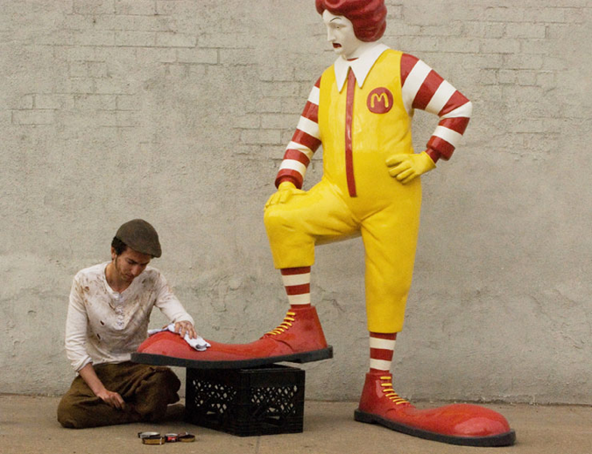 | “Shoeshine for Ronald”  Banksy  Life sized, fiberglass, mixed media, performance art  2013  Set up at McDonald locations throughout NYC for a month, the piece is a great example of cultural jamming. This work absolutely questions the desired public opinion McDonald’s desires to have in multiple ways. A servant shines extremely emphasized clown shoes as Ronald seems to judge the quality and disappointment of the job at hand. This work speaks in numerous ways including perhaps corporate worship, workplace conditions, or even the relationship McDonald’s food has on society unhealthily.  “How is Ronald treating this person?”  “Why do you think his shoes are even larger than the typical clown shoe?”
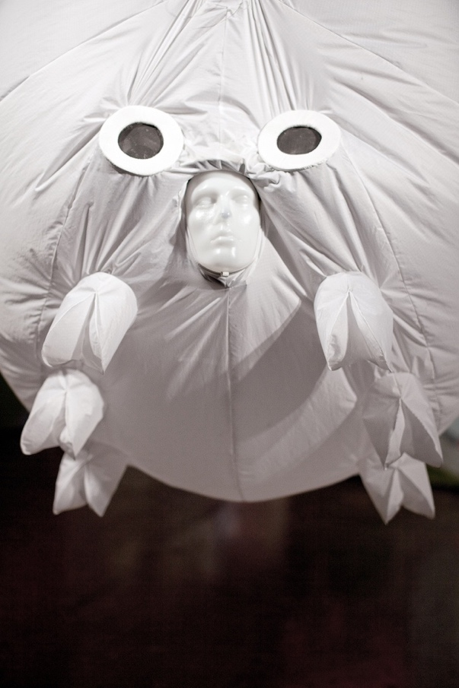 | The ENDURAsphere  The Yes Men  Fabric, Inflatable Suit  2010  Commenting on the ridiculous response to terrorism, The Yes Men, Andy Bichlbaum and Mike Bonanno, designed a special suit to be presented to the European Parliament representing themselves as a company called Global Security Response. The suit guarantees comfort when terrorism occurs, though only available to those who can afford them. The defensive orb presented was a hoax to highlight social issue. As an agent of positive change, this artwork provides subvertisment to many social problems, especially as serious as the art was taken as a solution and desired by members of the European Parliament. Some questions during the presentation included:  Q: Is it easy to swim with this suit if you must escape by river or sea?  A: Well, this is just a prototype, but the actual suit will be completely floatable, buoyant, and it's able to dive underwater as well to a depth, I think, of 30 feet.  Q: In Germany, in Cologne, we have problems with men touching women. Is this a solution for these problems?  A: I think that would be like throwing a nuclear bomb at a village to obliterate it. Um, I think there are probably other solutions to that problem.  Q: Do we have to wear it all the time? I'm thinking of human reproduction.  A: That's up to the user … if you feel safe at home, of course, take it off.  Q: Can this thing help us in the refugee crisis in Europe?  A: Uh, it's not really meant to help with the refugee crisis. I'm not sure how it might. I mean unless you fear refugees.
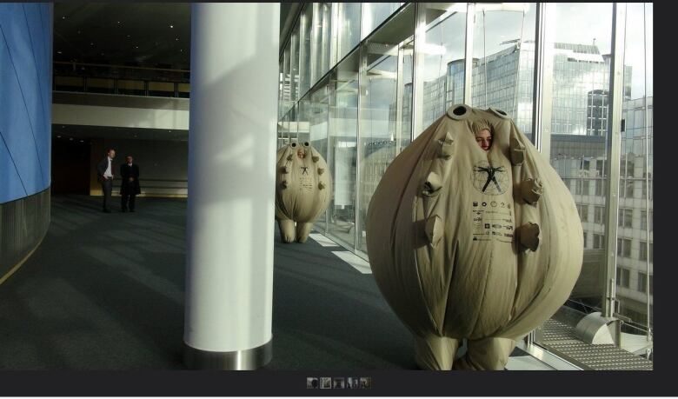 | Models demonstrate The ENDURAsphere at the European Parliament in Brussels on January 12th, 2016. The presentation was a hoax carried about by The Yes Men. (via YouTube)  Adds social performance art element to jam social issue directly instead of just visually.
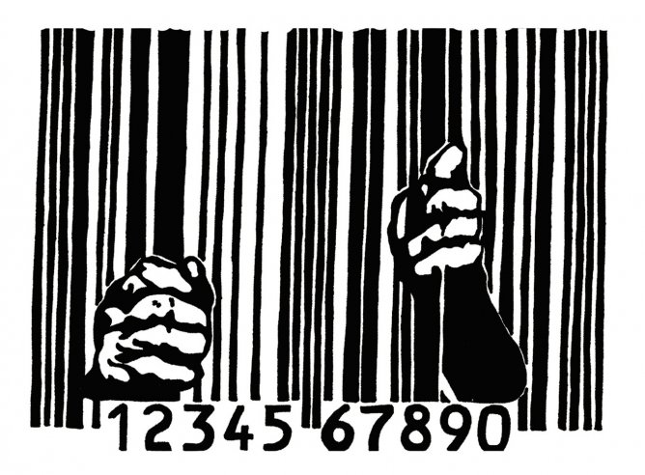 | Ad Jam #1  Banksy  Digital Media  “Why is the image of a UPC stamp depicted as bars in a prison here?”
 | McDonald’s Billboard  Digital Media  Zara A.  Australia  https://www.behance.net/search/images?search=subvertising  “What does this image say about McDonalds?”
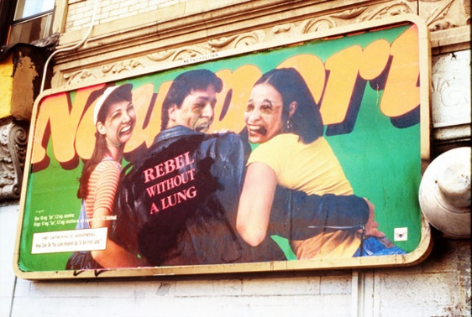  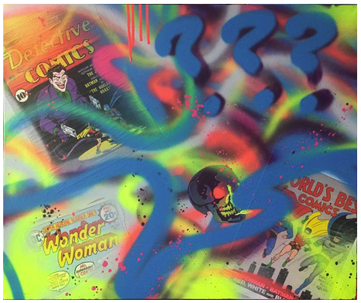 | “Rebel without a lung”  Jorge Rodriguez  Altered NYC billboard.  1994  “Why do you think the artist chose to paint the individual on the billboard the way he did?”  “Do you think it is COOL to have no lung like the text says?” “Why?”  http://www.fecalface.com/SF/features-mainmenu-102/2953-jorge-rodriguez-gerada-interview  “Comic Pop Print”  Acrylic and Spray paint  20”x 24” Canvas

6.4 Information about Related Artists, Styles, Movements, or Cultures (Include a short biography for all artists being shown in the lesson, links to artist websites, links to videos being shown in the lesson, and any information about genres, movements, cultures, time periods, or techniques included in the lesson. These should only be a few sentences long.)
- Resource 1 Banksy

Banksy started as a street artist in Bristol, England and is now well known for his political activism “graffiti” art. Using satire and sometimes dark humor, he secretly adds his work around the globe to public exteriors that have become very well known. His identity remains anonymous which adds mystery and intrigue to his artwork. He predominantly uses stencils in his work for more detail and recognition of meaning in his message. Using stencils originally were uses due to the speed and ability to use them to quickly make work also to not get caught graffitiing. His work is recognized today and highly sought after.

- Resource 2 The Yes Men

The Yes Men started as a culture jamming duo by Igor Vamos and Jacques Servin. It has now grown into a group/movement of anonymous users joining the mission to expose injustice, not just the two men. The two artists collaborated originally to raise public awareness on social issues both political and social. Often using satire, juxtaposition, and humor developing artwork that includes live performances including posing as official spokes persons for major organizations. Using fake designed websites, posts, interviews and even props, The Yes Men successfully change the stock market and raise awareness in social awareness platforms including, global warming, presidential candidacy, terrorism, and monopoly in general.

- Resource 3 Zara A.

Zara A. is a digital media artist from Australia. She predominantly uses vector art in her work, but also contributes to subvertising visuals while staying anonymous. Her work is displayed here:

- Resource 4 Jorge Rodriguez

Jorge Rodriguez was an immigrant exiled from Cuba and travelled to America at a very young age. He is very well known for his enormous portrait paintings reaching as large as 70 feet painted outside on grounds and side buildings incorporating the texture, shape, and forms of the canvass he paints upon. His early subvertisements including changing well recognized company dispelling marketing and common messages the adds typically conveyed. He evolved his artwork his more recognized work from there.

- https://urbanobservatory.wordpress.com/2011/03/29/jorge-rodriguez-gerada-interview-via-fecal-face-dot-com/

- Resource 5. Various anonymous underground artists

6.5 List of Instructional Resources, Materials, and References:

Carducci, V. (2006). Culture jamming: A sociological perspective. Journal of Consumer Culture, 6(1), 116-138.

Chung, S. K., & Kirby, M. S. (2009). Media literacy art education: Logos, culture jamming, and activism. Art education, 62(1), 34-39.

Darts, D. (2004). Visual culture jam: Art, pedagogy, and creative resistance. Studies in Art Education, 45(4), 313-327.

DeLaure, M., & Fink, M. (Eds.). (2017). Culture jamming: Activism and the art of cultural resistance. NYU press.

Freire, P. (2021). Pedagogy of hope: Reliving pedagogy of the oppressed. Bloomsbury Publishing.

Freire, P. (2020). Pedagogy of the oppressed. In Toward a sociology of education (pp. 374-386). Routledge.

How, M. L., & Hung, W. L. D. (2019). Educing AI-thinking in science, technology, engineering, arts, and mathematics (STEAM) education. Education Sciences, 9(3), 184.

Haleem, A., Javaid, M., Qadri, M. A., Singh, R. P., & Suman, R. (2022). Artificial intelligence (AI) applications for marketing: A literature-based study. International Journal of Intelligent Networks.

Ke, M. F. (2023). Applications and Challenges of Artificial Intelligence in the Future of Art Education. Pacific International Journal, 6(3), 61-65.

Lowenfeld, V. (1957). Creative and mental growth.

Mazzone, M., & Elgammal, A. (2019, February). Art, creativity, and the potential of artificial intelligence. In Arts (Vol. 8, No. 1, p. 26). MDPI.

Ng, D. T. K., Leung, J. K. L., Chu, S. K. W., & Qiao, M. S. (2021). Conceptualizing AI literacy: An exploratory review. Computers and Education: Artificial Intelligence, 2, 100041

Rong, Q., Lian, Q., & Tang, T. (2022). Research on the Influence of AI and VR Technology on Students’ Concentration and Creativity. Frontiers in Psychology, 13, 767689.
Sandlin, J. A., & Milam, J. L. (2008). “Mixing pop (culture) and politics”: Cultural resistance, culture jamming, and anti-consumption activism as critical public pedagogy. Curriculum inquiry, 38(3), 323-350.

Triputra, P., & Sugita, F. (2016). Culture Jamming Phenomenon in Politics (The Jokowi’s Memes in TIME Publication’s Cover and TokoBagus. com Advertisement). Journal of US-China Public Administration, 13(6), 386-396.

7. Integration/Connecting Links (interdisciplinary links such as geographical maps, word games, historical figures, contemporary issues, periodicals, etc.)

https://kristinadams.files.wordpress.com/2011/04/barcode-escape.jpg

https://art.newcity.com/2010/09/13/review-the-yes-menglass-curtain-gallery/

https://www.cbc.ca/radio/asithappens/as-it-happens-wednesday-edition-1.3402077/anti-terrorism-suit-presented-to-european-parliament-turns-out-to-be-hoax-1.3402246

https://medium.com/@cultagentz/the-culture-jamming-of-banksy-a-research-project-abfe96e8b085

7.1 Idea Mapping

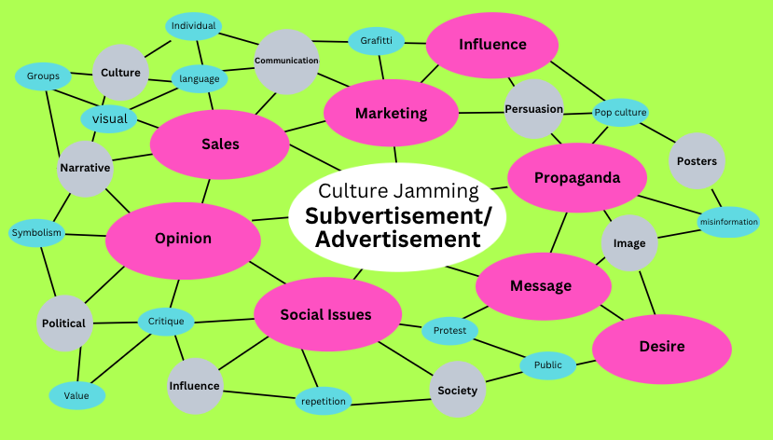

8. Management and Safety Issues:
Blade safety. Standards:
- Only carry them with the cap on
- Do not throw the knife!
- Do not use a dull blade.
- Use a cutting mat!
- Do not cut the tables.
- Score multiple times if need be.
- Cut away from yourself and others.
- Stay away from others within an arm’s reach while using (blood circle)
Fists up together as a group until silence is gained.

8.1 Organization of Supplies:
Day 1- Visual Board will be displayed daily. Power Point presentation will be on computer laptop daily for reference. All art materials will be brought every day for the entire project should someone get ahead or behind. Think sheets will be passed out by a chosen student and collected by the same at EOD. Back up jump drive will be used if computer won’t play. Name tags will be placed in the back tote folder labeled “Name Tags” daily.
Day 2-Visual Board will be displayed daily. Power Point presentation will be on computer laptop daily for reference. All art materials will be brought every day for the entire project should someone get ahead or behind. Paper, markers, air brushes and X-Acto blades will be set up at 3 different stations for three separate groups. Backup supplies will remain in a large tote in the back of the room. Extra paper, think sheets, and markers will be made accessible when needed.
Day 3-Visual Board will be displayed daily. Power Point presentation will be on computer laptop daily for reference. All art materials will be brought every day for the entire project should someone get ahead or behind. 2 students will be asked to set up workstations we used the week before. The same two students will help assist in putting them away.
Day 4-Visual Board will be displayed daily. Power Point presentation will be on computer laptop daily for reference. All art materials will be brought every day for the entire project should someone get ahead or behind. Same as day 3
Day 5-Visual Board will be displayed daily. Power Point presentation will be on computer laptop daily for reference. All art materials will be brought every day for the entire project should someone get ahead or behind. Same as day 3
Day 6-Visual Board will be displayed daily. Power Point presentation will be on computer laptop daily for reference. All art materials will be brought every day for the entire project should someone get ahead or behind. Students will be asked what materials are left and place them in the back-room tote. They can keep their name tags.

  - Clean-up of Supplies:

Day 1- One student supervisor will be chosen daily to review the quality of final clean up. Daily student chosen for picking up think sheet/sketches/project folder will rotate for delivery to the back-room tote. All materials will have an appropriate vessel (i.e., scissors holder, pencil box, marker box) and the class made responsible for getting to their appropriate place. A clean up responsibility chart will be made designating who has what responsibility daily and will rotate weekly. This includes responsibility for floors, tabletops, chairs, and organizing the tote.
Day 2-Students will be asked to start cleaning up at EOD and put back their supplies into the totes. Daily encouragement will continue for improvement and best the last time we cleaned. This includes the use of cleaning supplies/Windex, and the chosen supervising student of the day checking off the checklist duties have been done on the rotating responsibility sheet. Students to make sure the workstations are clean. Final assessment done by teacher determines the next week’s supervisor.
Day 3- Students will be asked to start cleaning up at EOD and put back their supplies into the totes. Daily encouragement will continue for improvement and best the last time we cleaned. This includes the use of cleaning supplies/Windex, and the chosen supervising student of the day checking off the checklist duties have been done on the rotating responsibility sheet. Students to make sure the workstations are clean. Final assessment done by teacher determines the next week’s supervisor. Extra focus on air gun spraying area should take place. Blades should be assessed and replaced if needed.

Day 4- Students will be asked to start cleaning up at EOD and put back their supplies into the totes. Daily encouragement will continue for improvement and best the last time we cleaned. This includes the use of cleaning supplies/Windex, and the chosen supervising student of the day checking off the checklist duties have been done on the rotating responsibility sheet. Students to make sure the workstations are clean. Final assessment done by teacher determines the next week’s supervisor. Blades should be checked and replaced if needed.

Day 5- Students will be asked to start cleaning up at EOD and put back their supplies into the totes. Daily encouragement will continue for improvement and best the last time we cleaned. This includes the use of cleaning supplies/Windex, and the chosen supervising student of the day checking off the checklist duties have been done on the rotating responsibility sheet. Students to make sure the workstations are clean. Final assessment done by teacher determines the next week’s supervisor.

Day 6- Students will be asked to start cleaning up at EOD and put back their supplies into the totes. Daily encouragement will continue for improvement and best the last time we cleaned. This includes the use of cleaning supplies/Windex, and the chosen supervising student of the day checking off the checklist duties have been done on the rotating responsibility sheet. Students to make sure the workstations are clean. Final assessment done by teacher determines the next week’s supervisor.

- Critical Comments and Reflection

I have many takeaways and surprises I learned from my six days of student teaching. Understanding the time restraints, I would encounter and try to accommodate beforehand. I was still amazed at how quickly 6 single classes went by so incredibly fast at 35 minutes. (with prayer and pledge) If I had not planned for this, I cannot imagine how difficult it would have been to accomplish my lesson objectives. I was surprised by the thorough completion and comprehension of the lesson plan, especially with the student artist statements. Collectively, they were so much more complex and thought out than I imagined they would be. I have attached some here. I was describing the lesson and feeling like a broken record, as one should. I was wondering if I was connecting more than I perhaps needed to. The artists' statements gave me the validity I needed and showed that they understood the lesson and learned impactfully and responsively. Another takeaway is knowing even further to keep improving (with the spirit of Kaizen I have) my overall efforts to be more organized in advance to promote more student time to work themselves. One must feel they aren’t planning enough to keep improving, even if they are, as it also highlights improvement opportunities. I keep asking, “What can I do more to prepare?” and “What else can I do to shave time in advance?” There are so many new opportunities for this; the more experienced I become, the more aware I remain of the need. The more efficiently time and the overall lesson plan can be provided to the students, the more impact the lesson can have. Having material ready, alarms and time schedules written out beforehand give conditions to focus and allow expediency, encouraging time for students to reflect and explore their creativity even more.

Looking at my students' finished work inspires me to provide more time for them to detail their work, fill in more cleanly, and not feel rushed, as you can see in almost all the work. The specific successes are certainly in the context of the lesson plan as their artist statements acknowledge a thorough understanding of new vocabulary particular to the individual student. This is true besides their responses to my continued open-ended questions I always ask. Also, when describing symbolism, their artist statements elaborated even what I could taught, personally related, and explained this in their work more amazingly than I could have imagined. This tells me my message sent was received. When I teach this lesson again, as I certainly will with improvements, allowing for time to sketch and focus on the work itself in just context will ensure a more poignant delivery of the message desired in their work that can be then received by an audience. When I have full control of time and a classroom of my own, I am sure even more understanding of the lesson will occur. Having my students become aware of how they are and can be target, influenced by the visual culture around them, especially tactics in advertising utilizing AI technology, will become even more precise and clear. As successful as I was at achieving this, I feel only more recognition and one on one would individualize both their group and own learning.

Scoring Rubric and Assessment Tools

Objectives | Low Level  Score | Medium Level  Score | High Level  Score
Objective I  Given a presentation on defining Cultural Jamming, advertising techniques and subvertising, students will clearly identify and evaluate aesthetic clues that convey messages in advertising. | Low standard of performance  Students did not clearly identify and evaluate aesthetic cues that convey messages in advertising | Medium standard of performance  Student satisfactorily identified and evaluated aesthetic cues that conveyed messages in advertising | High standard of performance  Student identified multiple aesthetic cues and evaluated cues to a high degree describing messages in advertising
Objective II  Given an ad on smoking Marlboro Cigarettes, students will successfully evaluate, discuss, and assess what the advertisement is also trying to sell if you smoke cigarettes. | Low standard of performance  Student did not successfully participate in evaluating, discussing or assess what Marlboro conveys if one smokes their cigarettes. | Medium standard of performance  Student satisfactorily participated in evaluating, discussing, and assessed what Marlboro conveys if one smokes their cigarettes. | High standard of performance  Student evaluated, discussed, and assessed what Marlboro conveys if one smokes their cigarettes in multiple ways to a high degree.
Objective III  Given a definition of Subvertisement, students will artistically and effectively incorporate Subvertisement in their artwork/design. | Low standard of performance  Student did not effectively use subvertisement in their artwork/design. | Medium standard of performance  Student satisfactorily incorporated subvertisement in their artwork/design | High standard of performance  Student incorporated subvertisement in multiple unique and creative high degrees
Objective IV  Given multiple current examples of subvertising, students will creatively design their own logo displaying a message of their own clearly changing a modern logo design to better signify their personal reality/understanding. | Low standard of performance  Student did not display a clear message, use a modern logo, clearly changing message to their personal message | Medium standard of performance  Student used a clear message, a modern logo, and clearly changed the message to their personal message | High standard of performance  Student transformed a modern logo clearly while changing their intended message personally to a high degree creatively
Objective V  Given a presentation, students will successfully interpret and learn how visual and aesthetic cues are used to target and manipulate an audience. | Low standard of performance  Student did not interpret and learn how visual cues and aesthetics cues are used to target and manipulate an audience | Medium standard of performance  Student interpreted and learned visual cues and aesthetic cues and how they are used to target and manipulate an audience | High standard of performance  Student understands and interprets visual and aesthetic cues and how they target and manipulate an audience to a high level of degree
Objective VI  Given a presentation on Cultural Jamming, students will cleanly map/draft an idea sketching of their thought process. | Low standard of performance  Student did not cleanly map/draft an idea sketch/rough draft of their thought process | Medium standard of performance  Student cleanly mapped/drafted an idea of their thought process | High standard of performance  Student very cleanly mapped/drafted and articulated their ideas and thought process
Objective VII  Given paper, colored pencils, air brushes, and a presentation preparing/making stencil, students will include stencil use and utilize text in their work. | Low standard of performance  Student did not use text and used only one material medium in stencil application | Medium standard of performance  Student satisfactorily used 3 mediums, text, and used a stencil | High standard of performance  Student used a minimum of 4 mediums, used text clearly and stencils in multiple ways
Objective VIII  Given markers, paint, magazines, and digital prints of contemporary advertisement, students will thoughtfully declare and develop a clear message in their artwork. | Low standard of performance  Student did not thoughtfully declare or develop a clear message in their artwork using markers, paint, magazines, and digital prints of contemporary advertisements | Medium standard of performance  Student developed a clear message in their artwork using at least one each of markers, paint, magazines, and digital prints of contemporary advertisements | High standard of performance  Student developed a clear unique message in their artwork having used each available medium of markers, paint, magazines, and digital prints of contemporary advertisements

2. Handouts

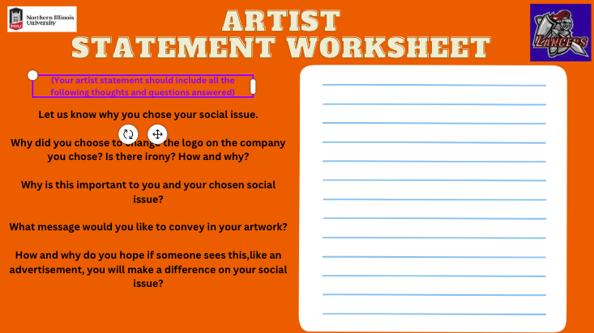
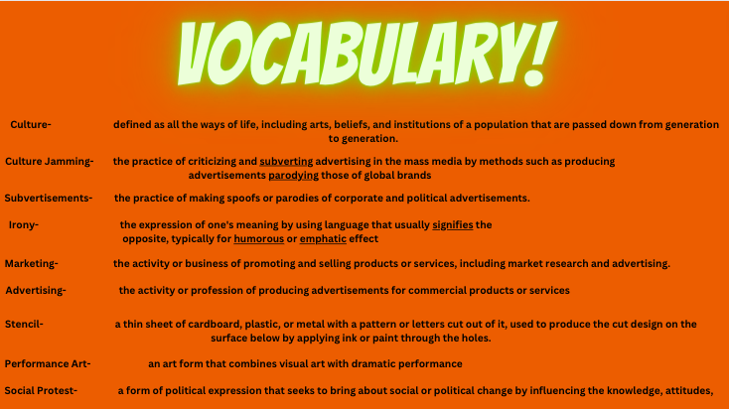
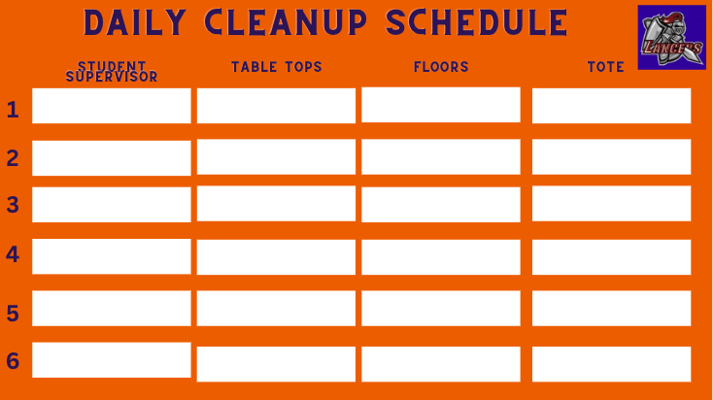
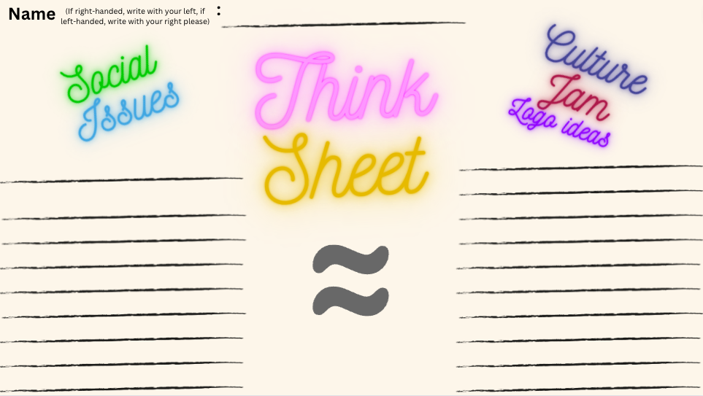
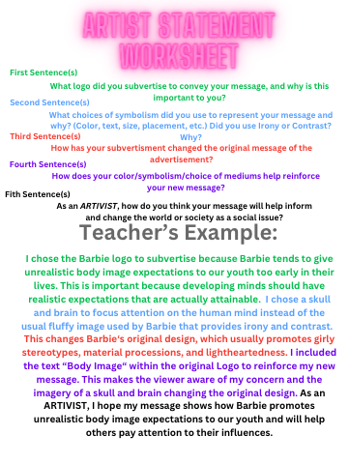

- Visual Board and Teacher Example

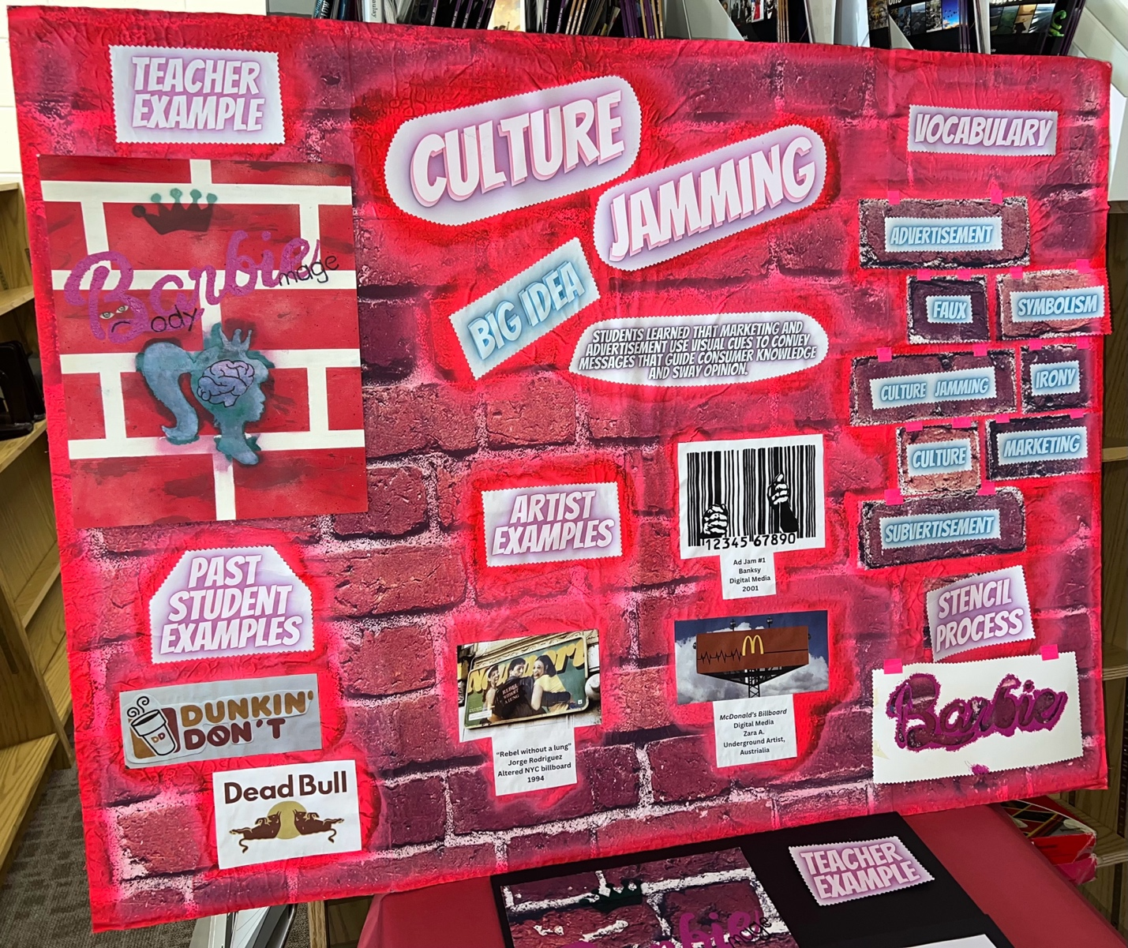
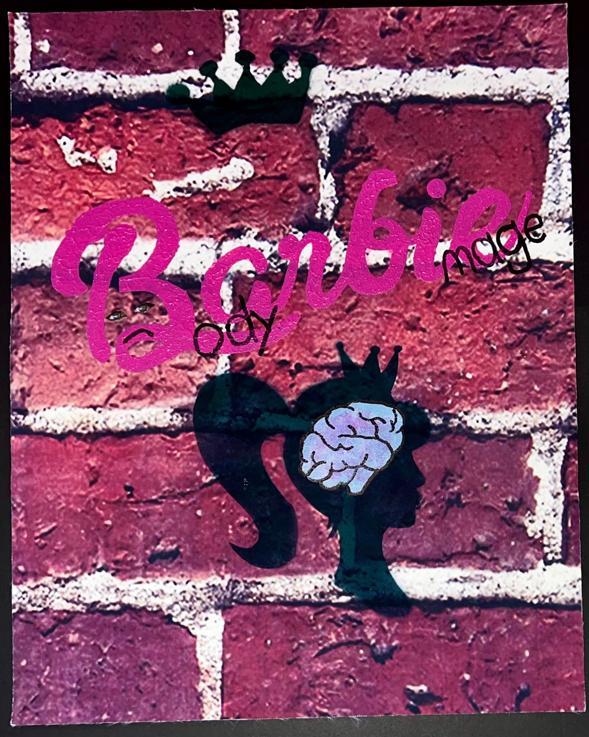
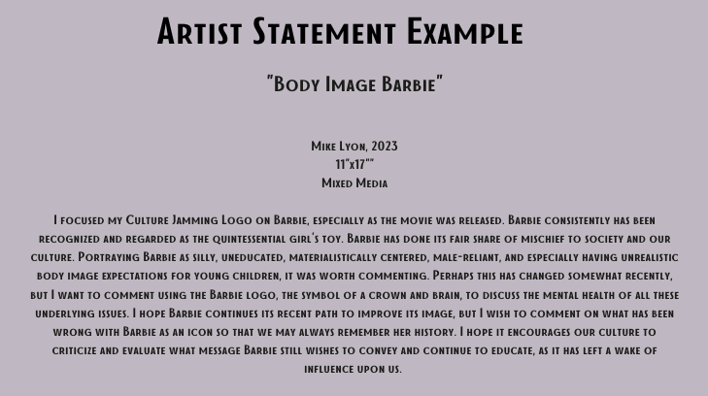

4. Visual Examples for Instruction

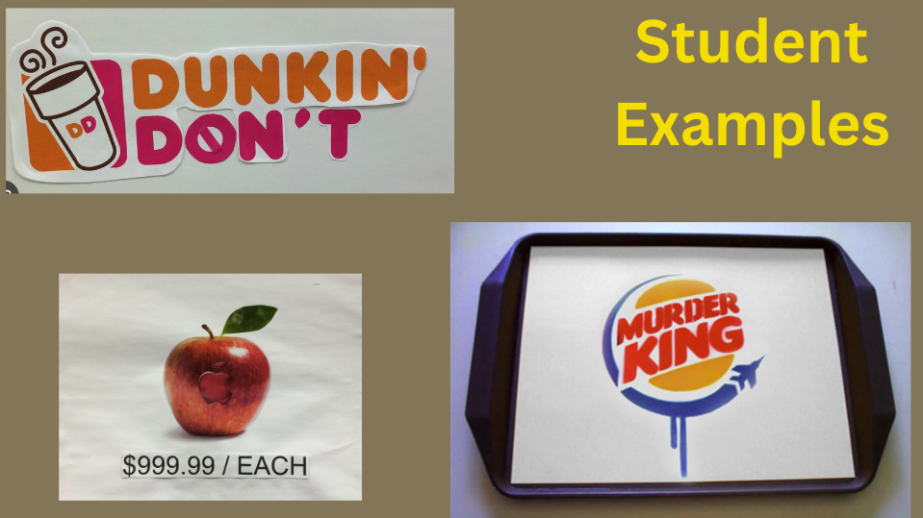
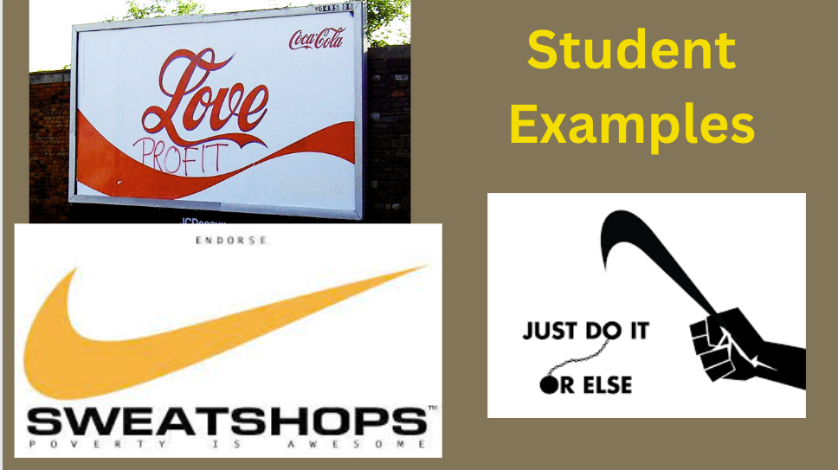

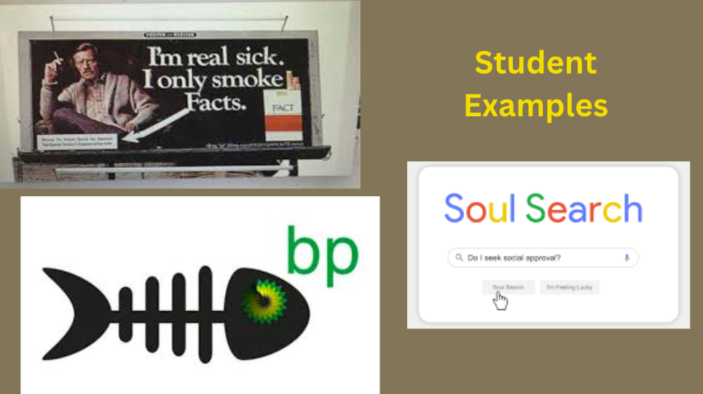

5. Students’ Artwork Examples and Artist Statements
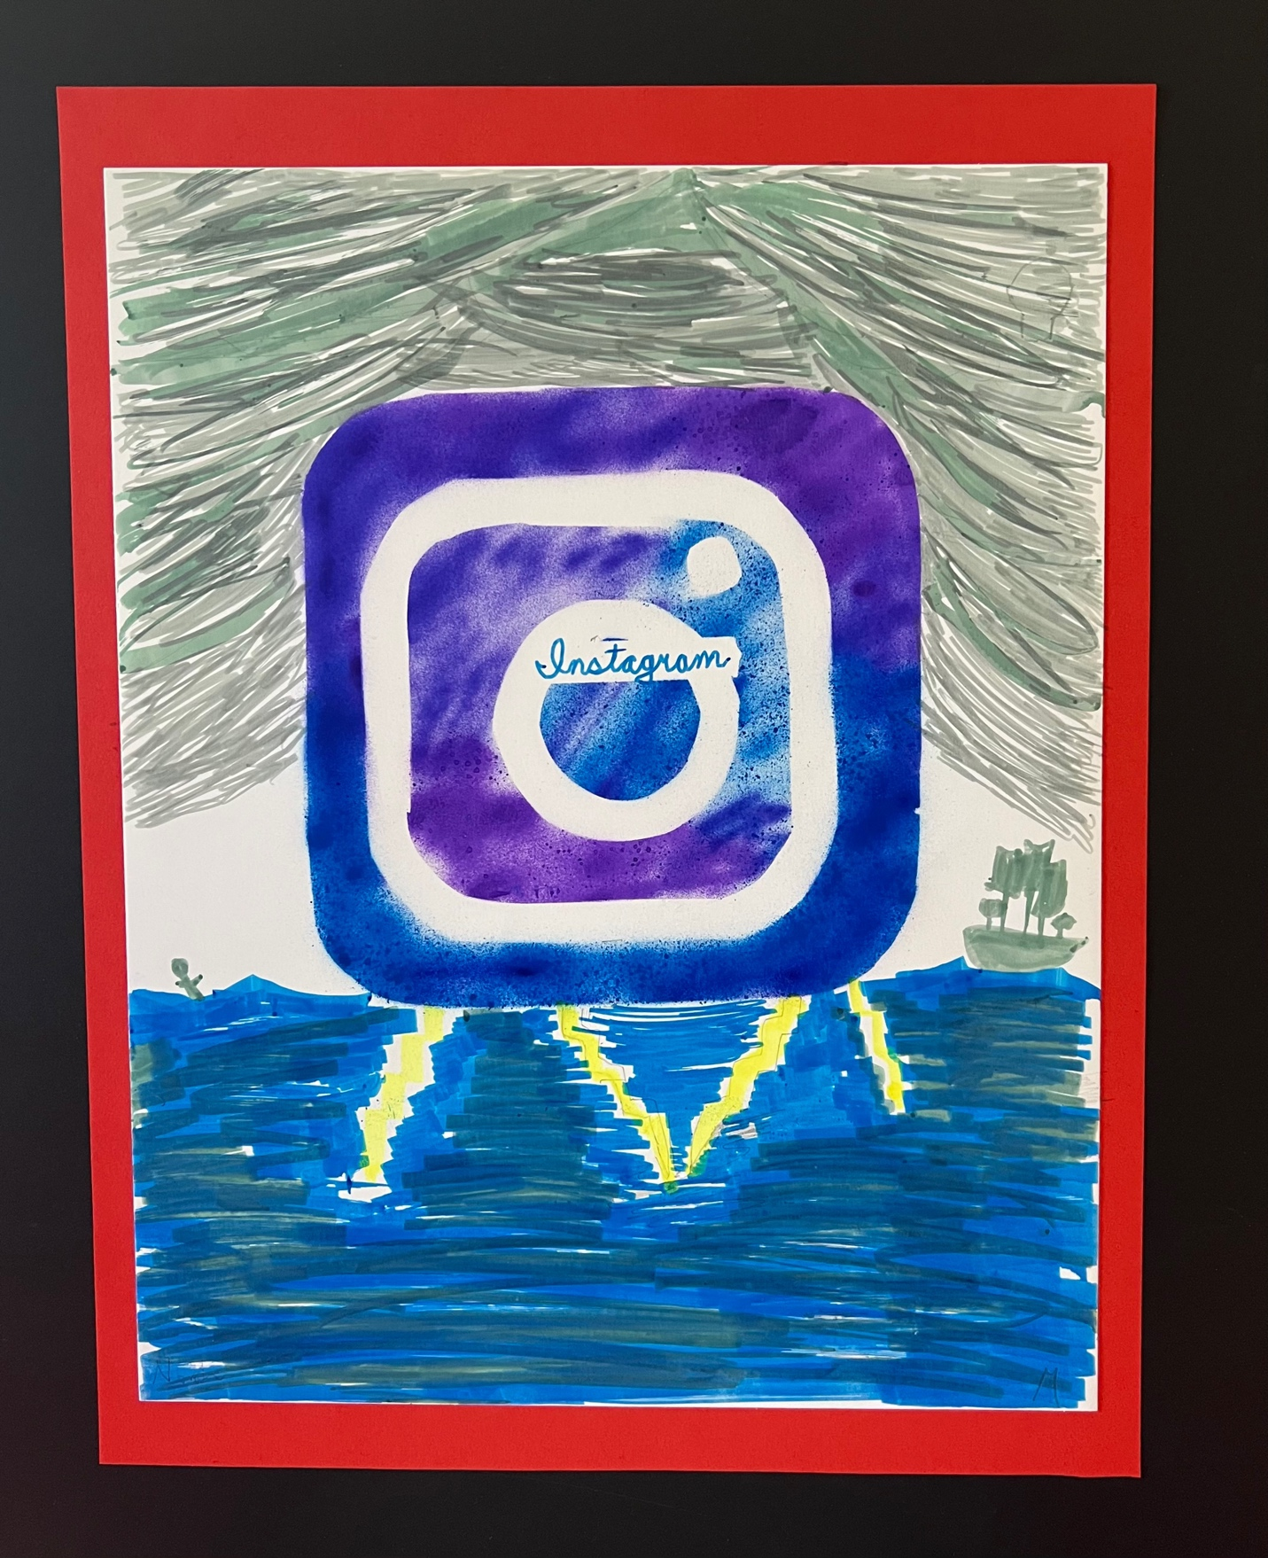
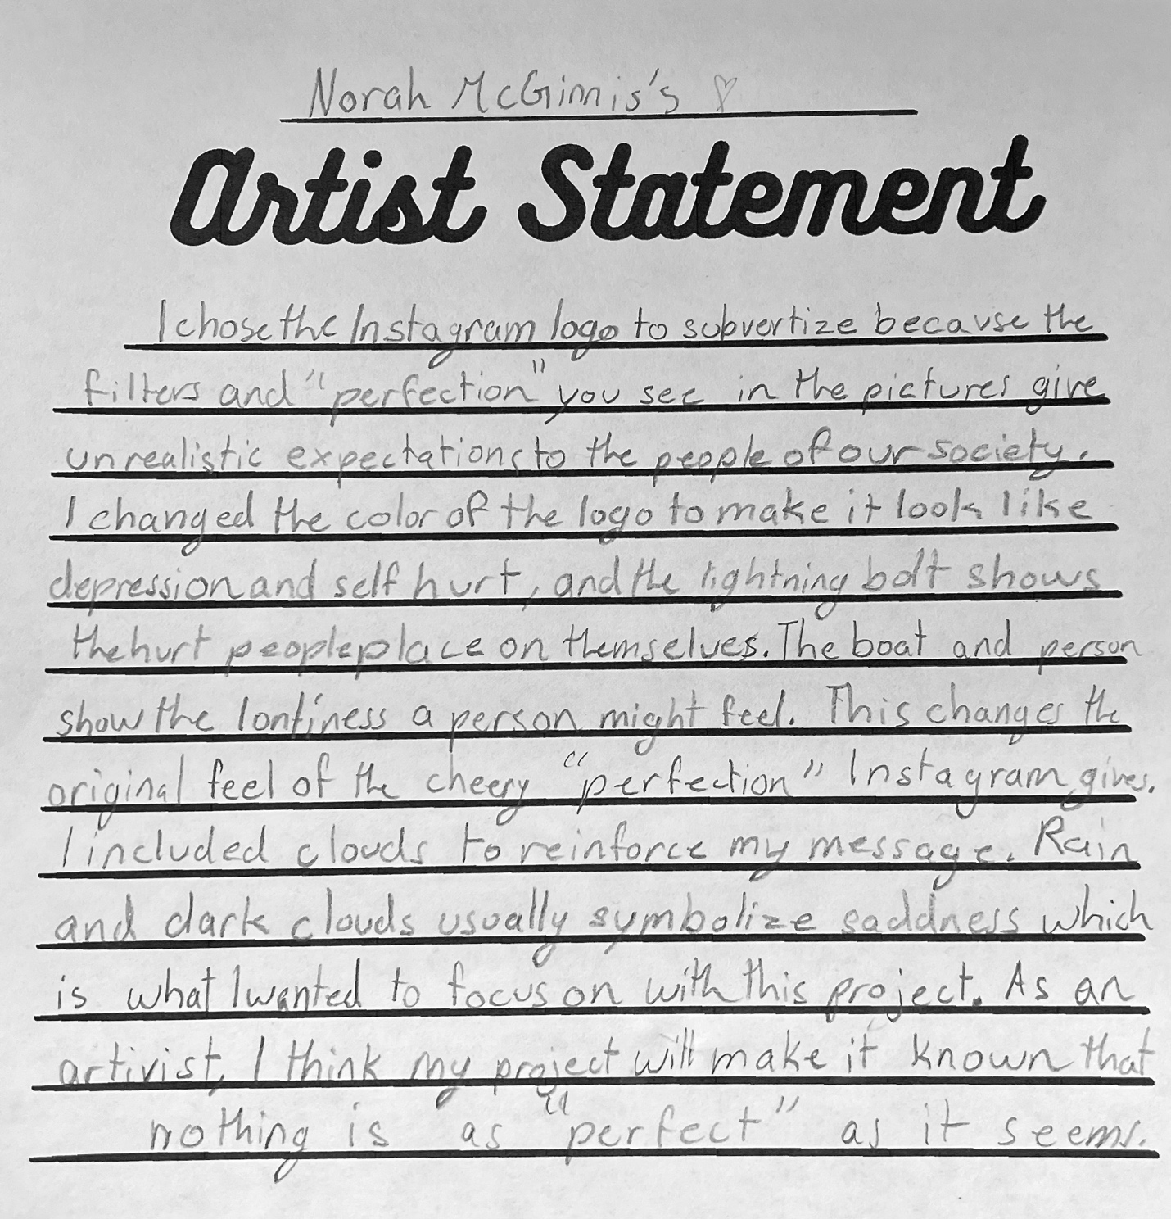

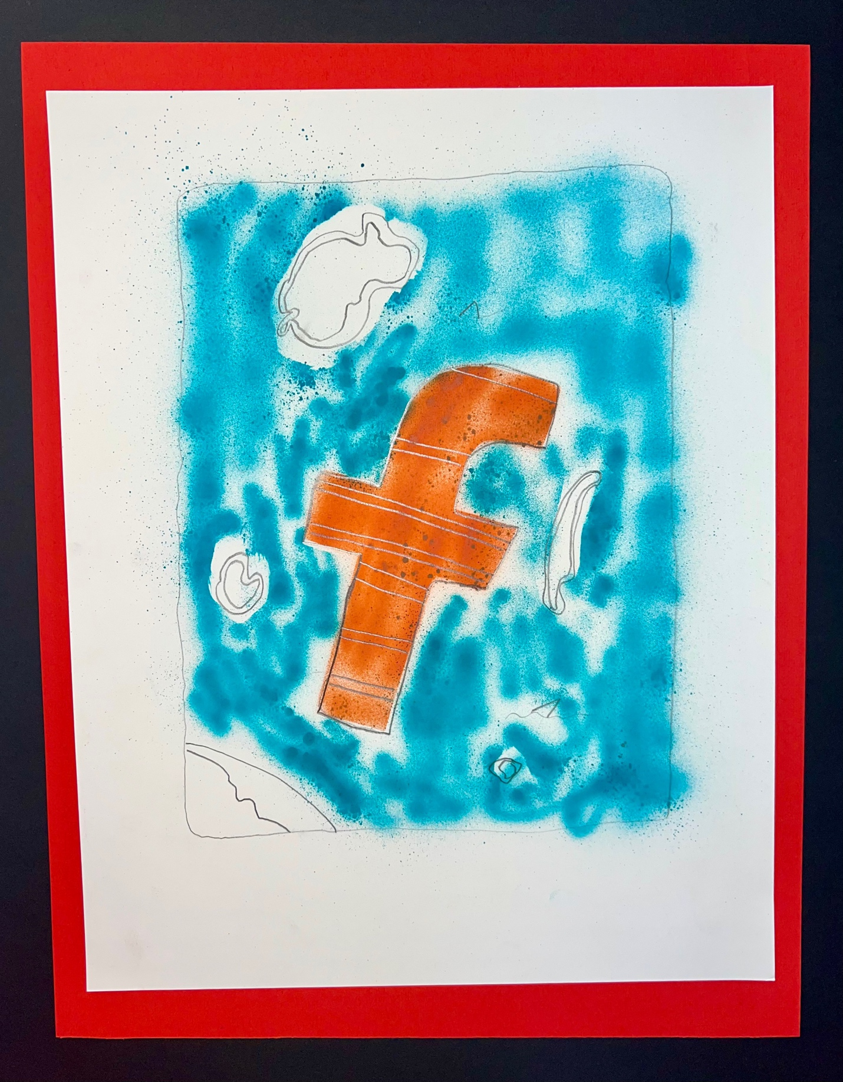
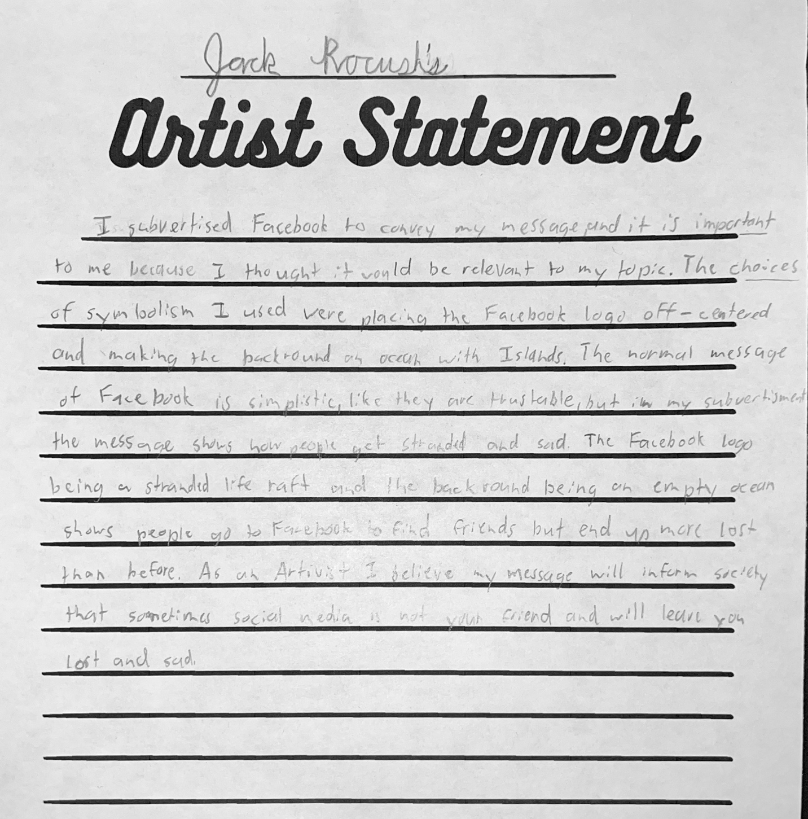

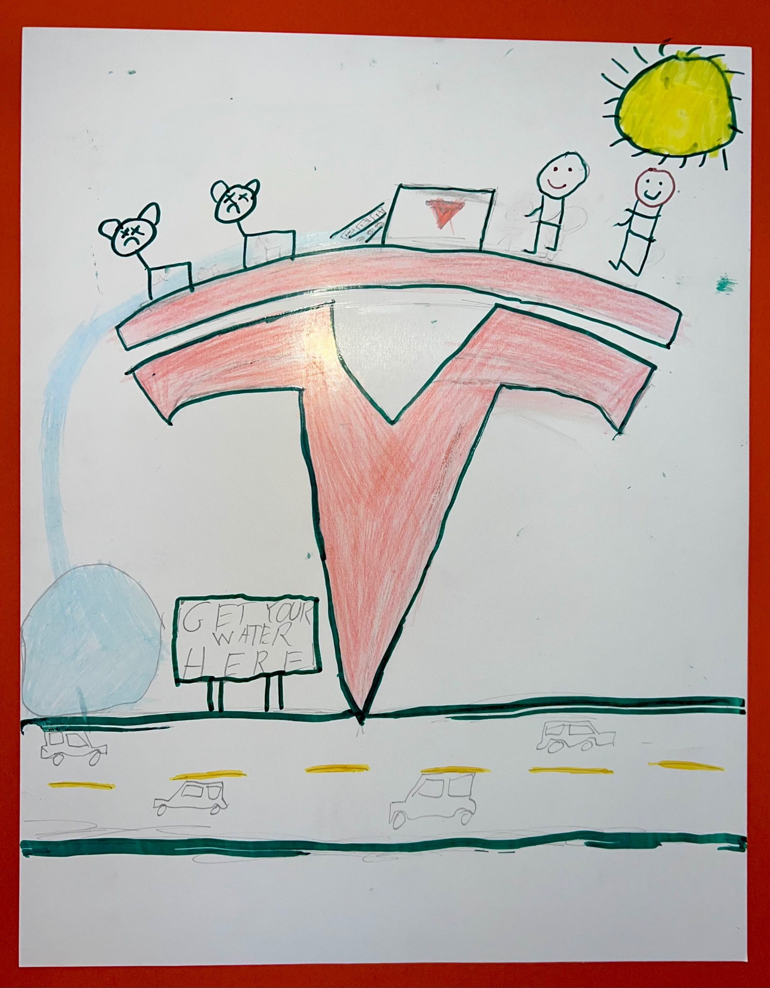

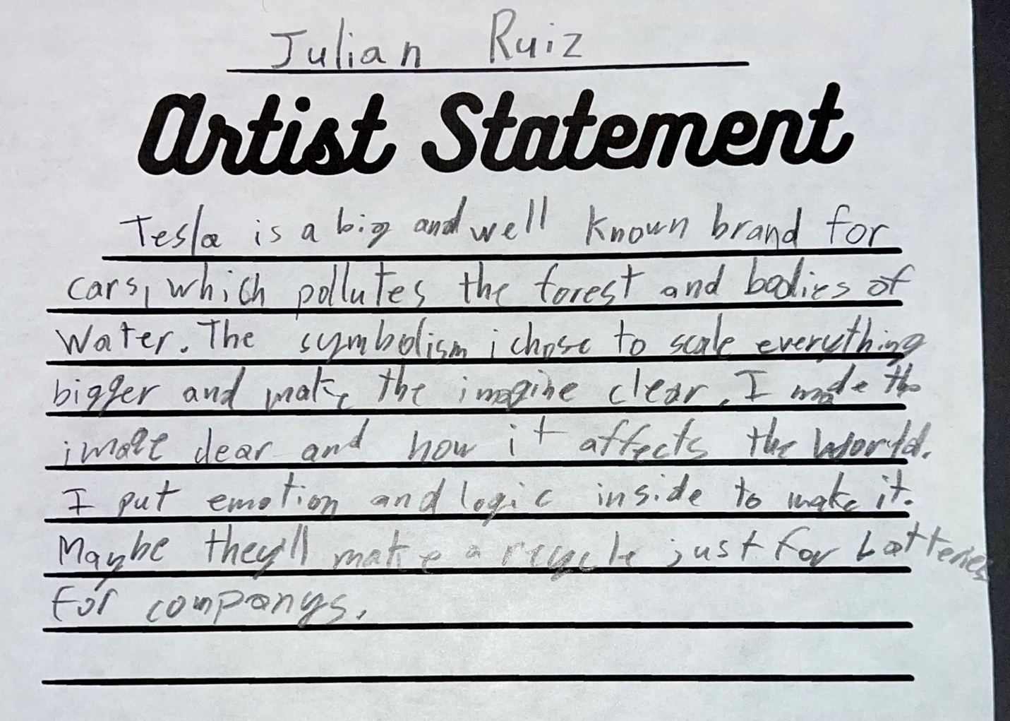
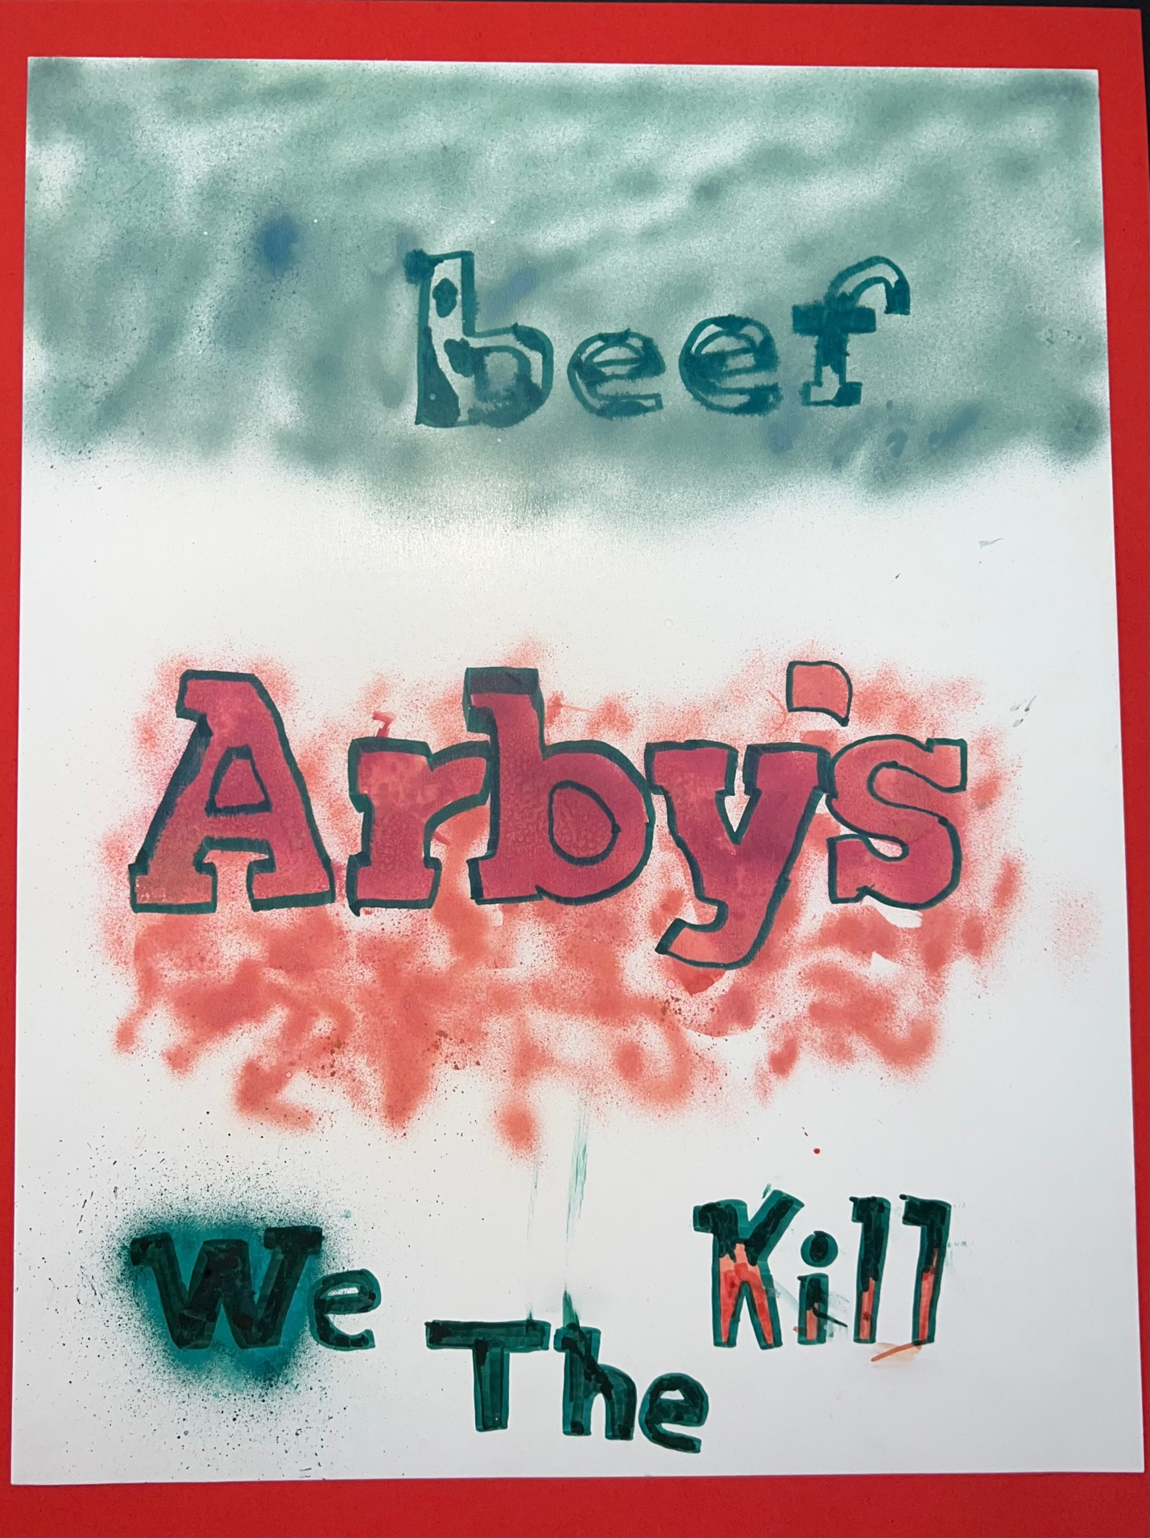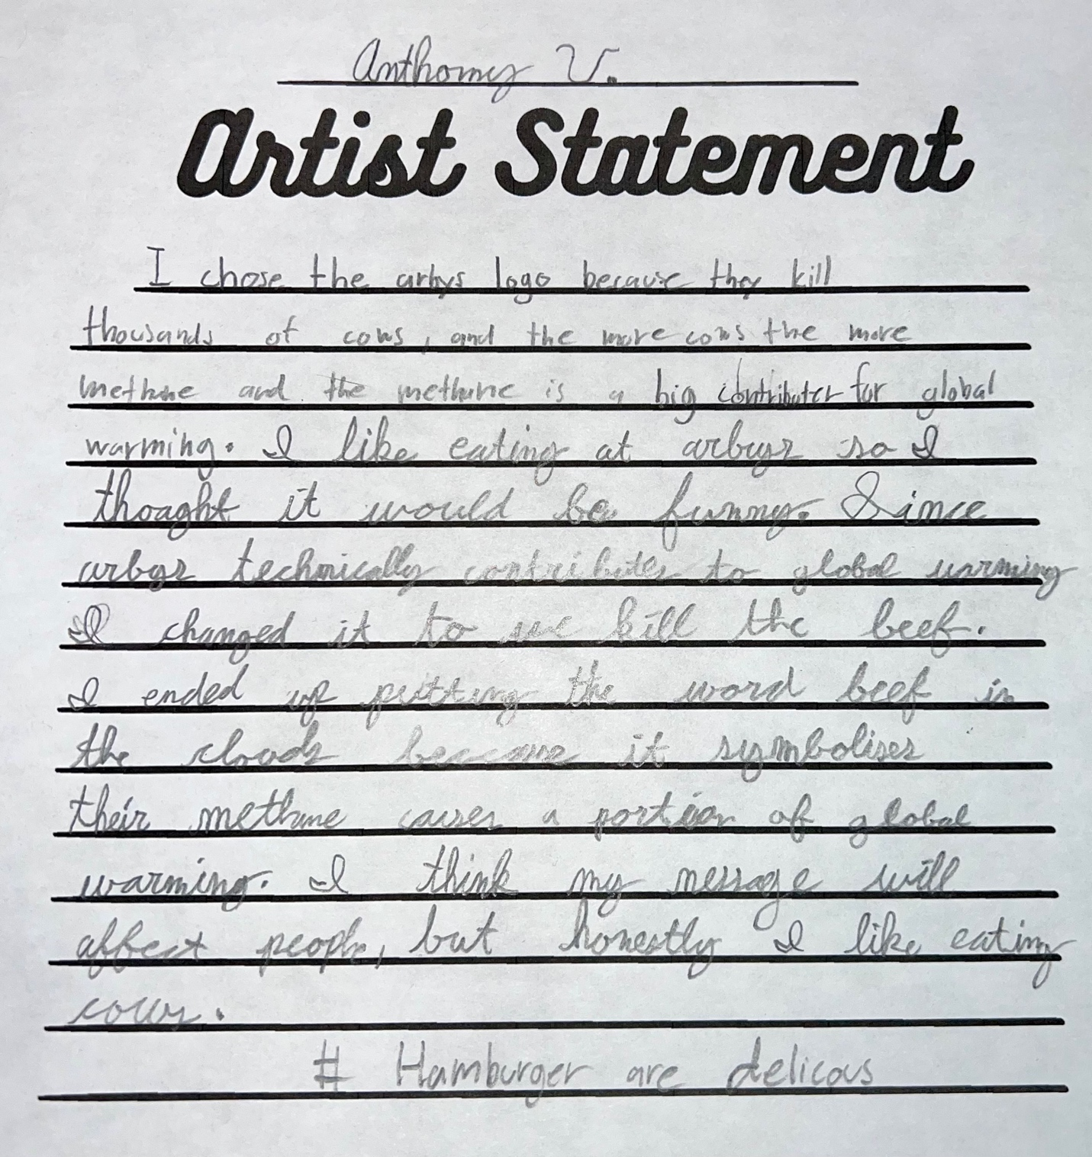
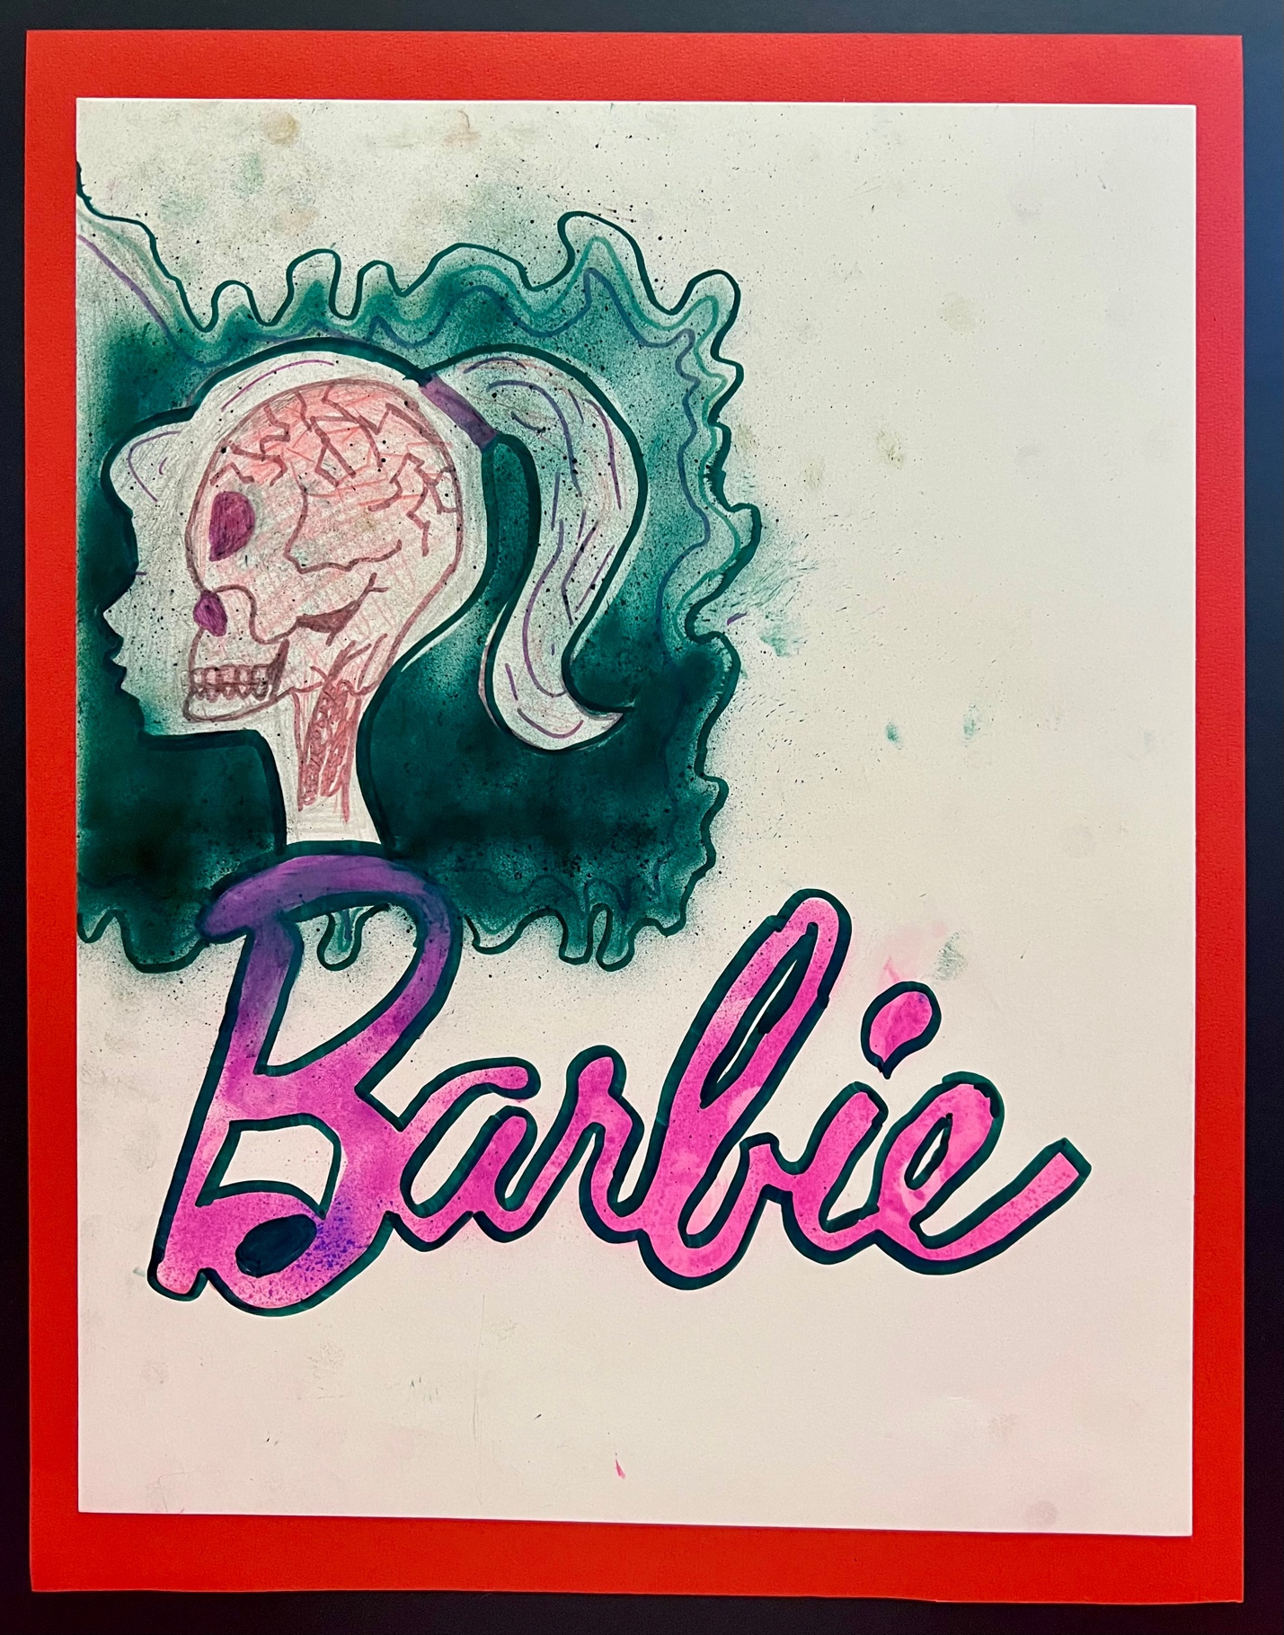
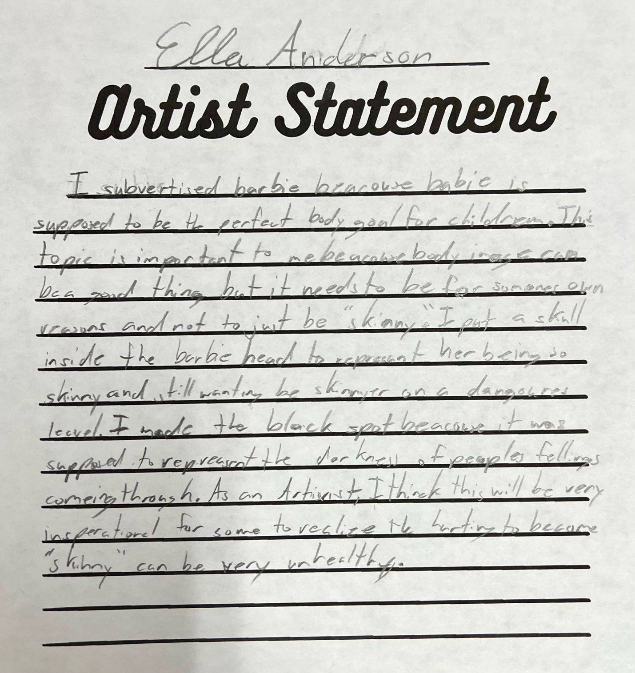

6. Class Photos and Clinical Teaching Exhibition Photos

